When you first start on insulin, you will usually be started on a very small ‘starter dose’. This dose will need to be increased or adjusted in line with your FASTING blood glucose levels.

General rules for altering your insulin doses:

- Alter insulin in response to a pattern of blood glucose results over period of 3-5 days.
- Doses are usually altered by 2 – 4 units at any time.
- Do not adjust on a one-off result.
- Monitor results of any changes for at least 3 days before making further changes.
- Check blood glucose levels regularly.
- Never just stop your insulin if you are ill. Seek medical advice first.
- Type 1 https://static1.squarespace.com/static/5a6439bab7411c94f2ebe216/t/609a5b5f616dd326ab736204/1620728672571/Sick_Day_Rules_T1DM.pdf
- Type 2
https://static1.squarespace.com/static/5a6439bab7411c94f2ebe216/t/609a5b78d996df0746c98055/1620728696630/Sick_Day_Rules_T2DM.pdf
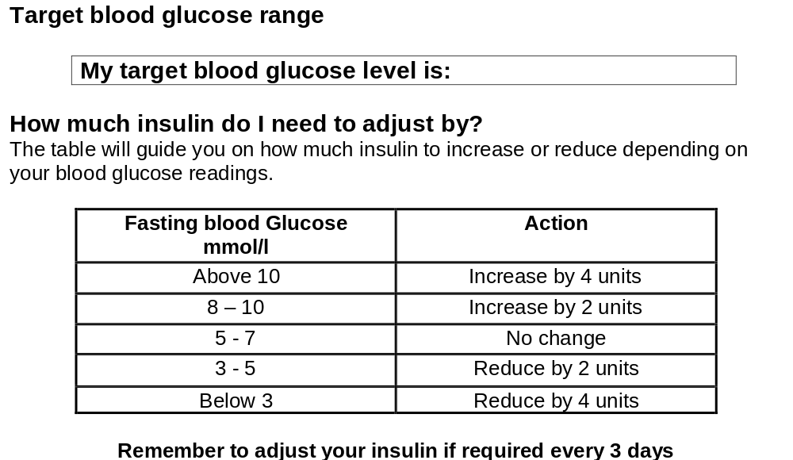
INDIVIDUALISED to patient

